My Favourite Town in Switzerland

My favourite town in Switzerland is Thun. While I have been living the past 22 years outside of Switzerland, namely in London, Sydney and Singapore, I was privileged to spend my childhood in Thun. This is the town where I grew up and have very fond memories of. Today I still have family in Thun and regularly return to my homeland. I have travelled the world and seen about 200 places and cities, but to me Thun still stands out as one of the most picturesque and most beautiful of all.
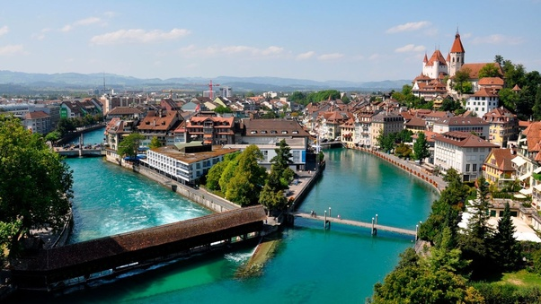
Put into the context of Switzerland, Thun isn’t exactly a small town, but in a wider international context it certainly is. Thun is Switzerland’s 11th largest town with about 45,000 inhabitants (around 90,000 people in the agglomeration). Thun is located at the bottom of Lake Thun and the river Aare flows through the town. High above the town towers the Thun Castle (Schloss Thun), which was built over 800 years ago by the Duke of Zaehringen. Within the old stone walls of the 12th-century castle is a fascinating museum dedicated to Thun’s ancient past.
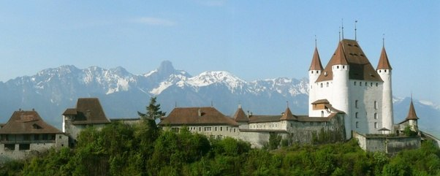
Close to the castle is the 14th century City Church. From the hill above the old town of Thun, housing the castle and the city church, one gets stunning views of Lake Thun and the Bernese Oberland. Besides tourism, machine and precision instrument engineering, the food industry, armaments and publishing are of economic importance to the town. Thun also hosts the largest military training area in Switzerland, which represents another important economic pillar for the town and the region.
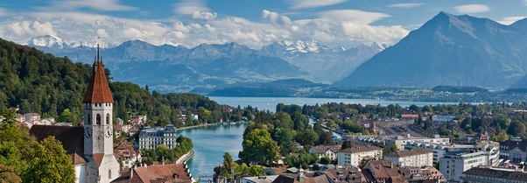
Thun and the region have an interesting and far back reaching history. The area of what is now Thun was inhabited since the Neolithic age (mid-3rd millennium BC). The name of the city derives from the Celtic term Dunum, meaning "fortified city". It fell to Rome in 58 BC, when Roman legions conquered almost all of Switzerland, and soon became one of the main centres of Roman administration in the region. The Romans were driven out of Thun, and out of the rest of Switzerland, by the Burgundians around 400 AD. The Aar became the frontier between the Christian Burgundians and the Pagan, German-speaking Alemanni, who lived north. Thun was mentioned for the first time during the 7th century, in the chronicle of Frankish monk Fredgar. The region of Thun became a part of the Holy Roman Empire in 1033, when Conrad II gained the title of King of Burgundy. The emperors entrusted the Zähringen family, centred in Bern, to subdue the unruly nobles of central Switzerland. Around 1190 Duke Bertold V of Zähringen, built a castle in Thun and expanded the city. After Bertold's death in 1218, his territories went to Ulrich III von Kyburg. In 1264 Thun received state rights and in 1384 the town was bought by the canton of Bern. Thun was the capital of the Canton of Oberland of the Helvetic Republic, which lasted from 1798 until 1803. In 1819 a Military School was founded in the city, which later developed into the main military school in Switzerland. Thun was connected to the railway network of Switzerland in 1859 and telephone access was made available in 1888.
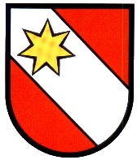
The arms have been used by the city of Thun since the 13th century. The original black star was replaced by the golden star after the Battle of Murten in 1476. The arms are also used by the district of Thun, founded in 1803. Beside having received the golden star, the Battle of Murten still has a place in Thun’s traditions today. During the battle the warriors from Thun captured Charles the Bold’s court jester. Nowadays, the court jester, who is called the Fulehung, is the main character of the annual Marksmen’s Festival (Ausschiesset) in Thun. The Fulehung is equipped with mask, pig’s bladder and nightstick and chases the crowd through the streets of Thun’s old town while handing out candy to the kids.
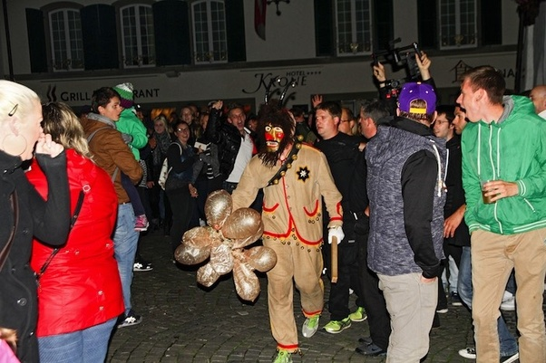
Another longstanding tradition of Thun is the cadet corps. It goes back to 1839 when a new cadet corps was added to the Progymnasium with the aim to accustom the students to military order and discipline and to prepare them by means of weapons exercise to defend their homeland. After the two world wars, the Thun cadet corps had to adapt itself to changing times. Military forms were reduced and replaced by sports activities. These activities were abseiling at first, then athletics and later swimming and orienteering. This resulted in the transformation of the cadet corps from a military school corps into a modern sports organisation. In 1972 the compulsory part for the Progymnasium students was abolished and since 1972 girls are admitted to the cadet corps.
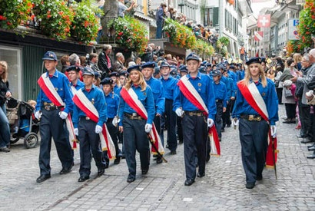
The Thun cadet corps is firmly rooted in the town’s population, which is underpinned by the large attendance of the local population at the annual Ausschiesset. The city council of Thun is also supporting the cadet corps, has placed it on a legal footing in 1962 and declared the community of Thun as its bearer. As a result, today the cadet corps is a public institution of the city of Thun and can be joined on a voluntarily basis by all boys and girls from age 11 to 16. The current corps is 330 cadets strong, half of it being girls. The sports program consists of athletics, football, handball, floorball, swimming, orienteering and volleyball.
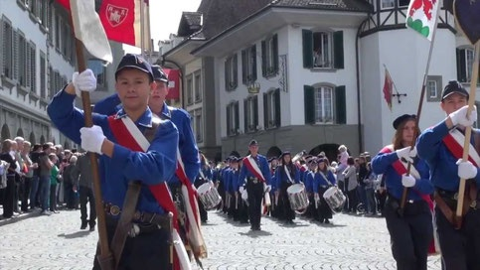
Thun is often referred to as the “Gate to the Bernese Oberland”, one of the most beautiful places in Switzerland and the Alps. The main peaks of the Bernese Oberland, Eiger, Moench and Jungfrau can be seen towering over the Oberland from Thun. In between the two majestic peaks Moench and Jungfrau is the Jungfraujoch, at an altitude of 3,466 meters called the Top of Europe, which can be reached by a railway that makes its way through a complex construction of tunnels to reach that altitude.
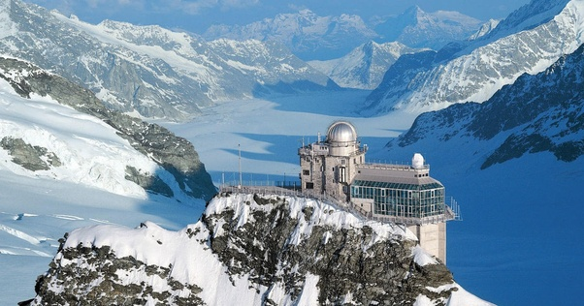
Another beautiful peak in the Bernese Oberland is the Schilthorn, which is 2,970 meters above sea level and offers a magnificent view of the Alps and the “Swiss Skyline” Eiger, Moench and Jungfrau. Piz Gloria was one of the places where the James Bond movie “On Her Majesty’s Secret Service” was filmed in 1963.
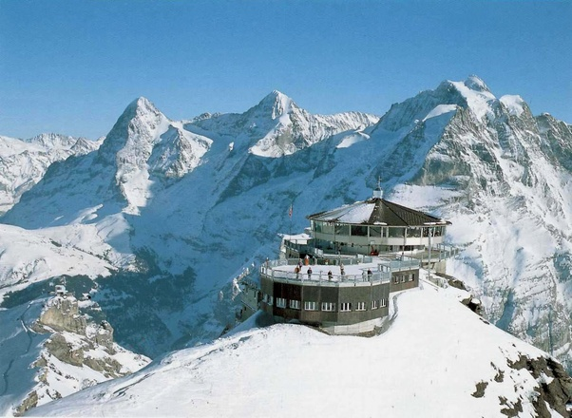
The two peaks in Thun’s immediate vicinity are Mount Stockhorn and Mount Niesen. The Stockhorn is 2,190 meters high and accessible via a cable car from Erlenbach im Simmental.
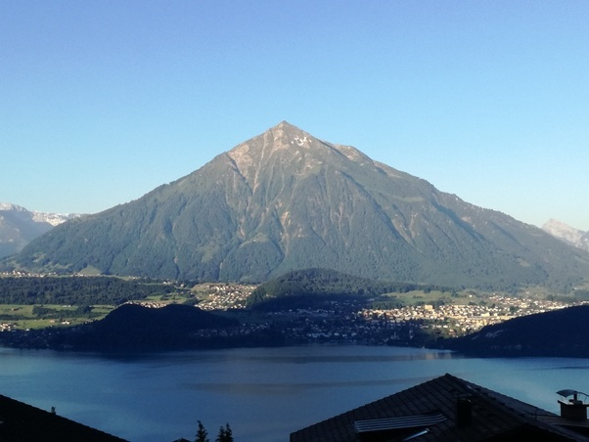
The Niesen peaks at 2,362 meters above sea level and can be easily reached by using the Niesenbahn funicular, which starts from Muelenen. The Niesenbahn construction was completed 108 years ago.

An alternative to reach the Niesen summit by foot offers the world’s longest stairway, which was built alongside the funicular. The stairway contains 11,674 steps. A little hint here: walking down all these stairs is actually harder on the legs than waking up all the way.
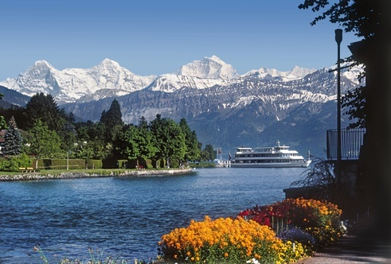
The Lake of Thun, in the midst of the Bernese Oberland, is surrounded by an amazing mountain scenery, a myriad of cosy villages, and the charming towns of Thun and Interlaken. Boats sail Lake Thun all year round. In summer the magnificently restored historic paddle steamer “Bluemlisalp” plies the lake.
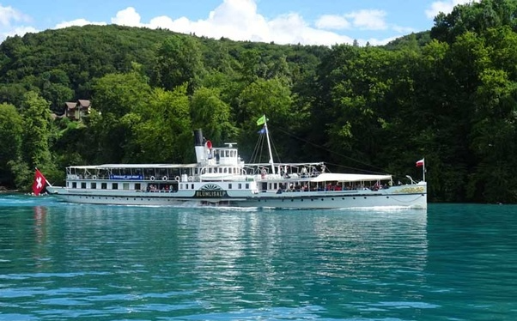
On the sunny southern slopes between Thun und Merligen subtropical vegetation flourishes, while on the opposite side of the lake, in the Bay of Spiez, which is presided over by another beautiful castle, you will find small vineyards. Not to be missed are the twelve one-thousand-year-old Romanesque churches that dot the coastline. One of them is the Scherzligen church in Thun, which is 1,256 years old.
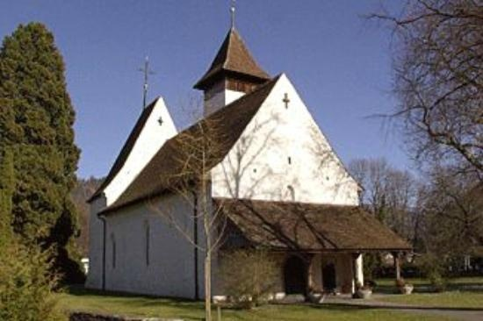
Right next to the Scherzligen church is the Schadau Park, which hosts another castle, the Schadau Castle, as well as Thun’s most modern congress hotel The Seepark and the Thun Panorama. The Thun Panorama was produced between 1809 and 1814 and was the first Swiss work of its type and the world’s oldest surviving example of its genre. The artist Marquard Wocher sketched the 360 degrees panorama while sitting on a roof in the Old Town of Thun. The incredible painting is 7.5 meters high and 38 meters long. The Panorama is housed in a purpose-built round building in the Schadau Park and provides an intimate look at life in Thun in the early 19th century.
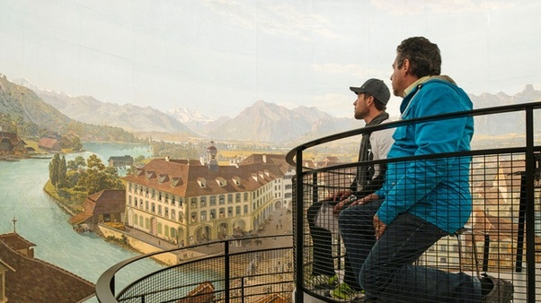
A part of Thun, which never fails to impress is the Old Town. The City Hall of Thun was built in the early 16thcentury and houses the City Council Hall and Thun’s archives. Adjacent to the City Hall is the Obere Hauptgasse, which consists of a street level and an elevated promenade level. The noble buildings in the Obere Hauptgase bare witness of a fascinating past.
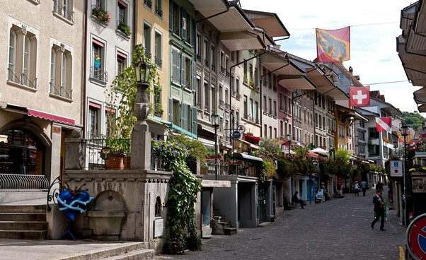
In the centre of Thun is the shopping Island Bälliz. Five bridges connect the shopping Island Bälliz with the medieval Old Town, the most interesting one being the wooden covered bridge "Untere Schleuse" (Lower Flood Gate), built in 1724 and re-constructed in 1788. The gates regulate the water flow of the River Aare.
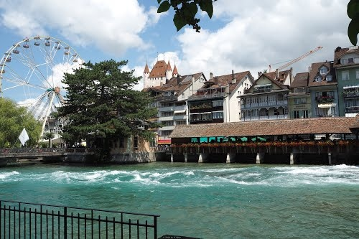
Thun also offers quite a variety for museum lovers or as alternative program on a rainy day. As mentioned earlier, the Historic Museum is housed in the Castle of Thun and featuring the history of Thun and the region. The Art Museum (Kunstmuseum) is located in the former “Thunerhof”, a 19th century luxury hotel and the first of its kind in Thun. The museum’s focus is mainly on contemporary art by Swiss and international artists. The place to see what children had to play with 50 to 150 years ago is the Toy Museum (Spielzeugmuseum) at the “Haus zum Engel”. Travel back in time and enjoy the wide collection of children’s toys.
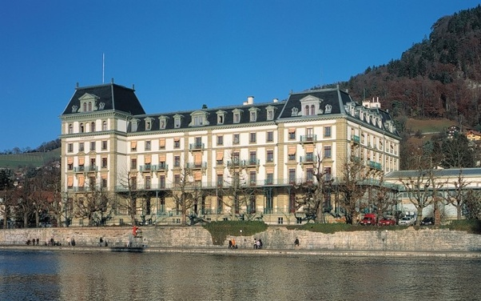
The Swiss Gastronomy Museum is housed in the former living quarters of castle servants of the Schadau castle in the Schadau Park. The museum contains information on cultural dining and drinking habits and relics of the Swiss Gastronomy. One special piece exhibited is the world’s smallest cookbook. And last but not least, there is a Wicker Museum, which is a private museum dedicated to basket weaving and contains close to 600 pieces of diverse basket ware and wickerwork from all over the world.
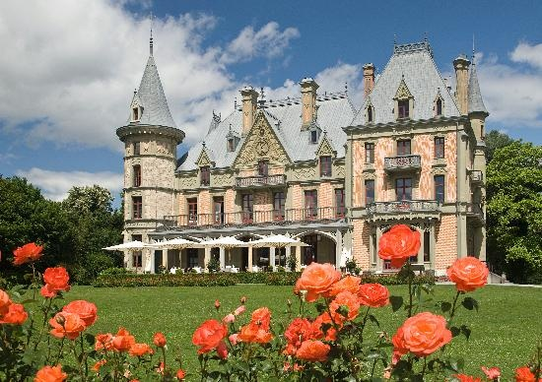
Entertainment wise there are also quite a number of interesting options in Thun. Beside the earlier mentioned annual Marksmen Festival “Ausschiesset”, Thun hosts the annual “Thunfest”, which is the largest city openair music festival in Switzerland, taking place in August. And there are the Castle Concerts Thun (Schloss Konzerte Thun), which is a series of concerts from classical to modern music held at various venues, such as the Thun Castle, the City Church or the Scherzligen Church. These events usually take place in June and have been ongoing for 45 years.
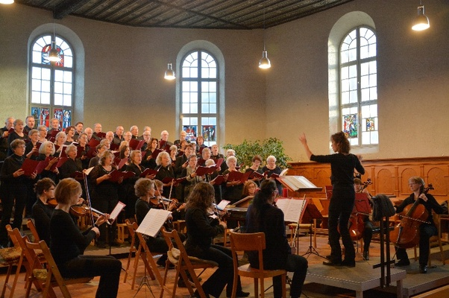
The “Thunerseespiele” is a musical on the most beautiful outdoor stage on the Lake of Thun with the Bernese alpine peaks Eiger, Moench and Jungfrau as backdrop. The Bach Weeks (“Thuner Bach Wochen”) are Bach concerts performed in Thun’s City Church, the Knights Hall at Castle Thun, the KKThun Concert Hall, and in the most beautiful and over 1,000 years old Amsoldingen Church just outside of Thun. The Bach Weeks usually take place around August/September.
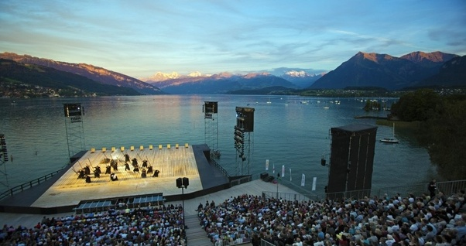
On the sports side Thun has a number of teams in different sports that play in respective Swiss national top leagues. The FC Thun is Thun’s football club, which plays in the Swiss Super League since being re-promoted in the 2009/2010 season. In the season 2005/06 FC Thun qualified as probably the smallest club ever for the group stage of the UEFA Champions League. They were twice only narrowly defeated by Arsenal, lost to Ajax twice and drew and beat Sparta Praha, which meant fninishing 3rdin the group and qualifying for the Europa League Round of 32, where they were beaten by the German Hamburger SV over two legs. FC Thun play at the Stockhorn Arena in Thun, a stadium with a capacity of 10,000 people.
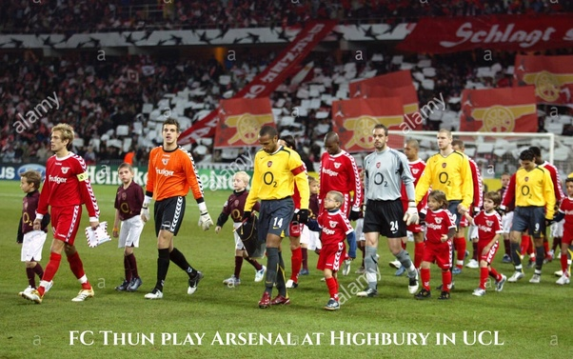
Wacker Thun is Thun’s handball team, which plays in the top Swiss Handball League. Wacker Thun won the title of Swiss Champions twice in 2013 and 2018 and also emerged as victors at the European Handball Federation Challenge Cup in 2005. The DHB Rotweiss Thun is Thun’s ladies handball team, which since 1993 plays in the Spar Premium League SPL, the highest league of Swiss ladies handball. DHB is an independent club and was for a long time the only ladies handball club in the region since founded in 1970. Furthermore, the Unihockeyclub Thun (UHC Thun) plays in the NLA, the top Swiss unihockey league, the SC Thunerstern participates on top national level in the Swiss Rollhockey NLA, and in ice hockey the EHC Thun plays in the MySports League, which is the 3rdSwiss ice hockey league.
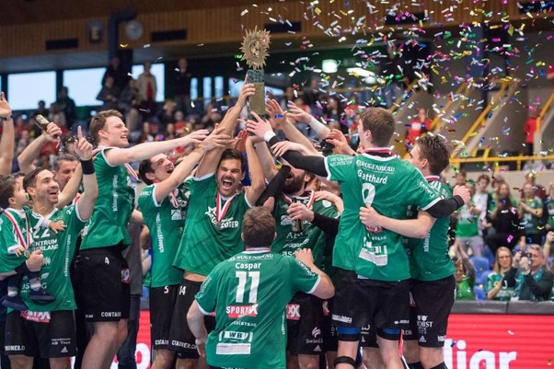
I hope this write up about my favorite Swiss town Thun was informative and may inspire one or the other person to visit my gorgeous hometown and the Bernese Oberland in Switzerland.
2.6k views · View Upvoters

